As-Is Process Flow

Project Name: ABC School Web and Mobile Application
Prepared by: Shiv Satyam Singh

Purpose
This document shows the current manual attendance process used by ABC School before introducing the new web and mobile application.

Current Attendance Process
- Teacher enters the classroom.
- Teacher opens the attendance register or attendance sheet.
- Teacher calls student names one by one.
- Teacher marks each student as Present or Absent.
- Teacher confirms the attendance sheet.
- Teacher submits the attendance sheet to Admin Staff.
- Admin Staff checks the attendance sheet.
- Admin Staff stores the attendance record manually.
- Admin Staff prepares an attendance report only when required.

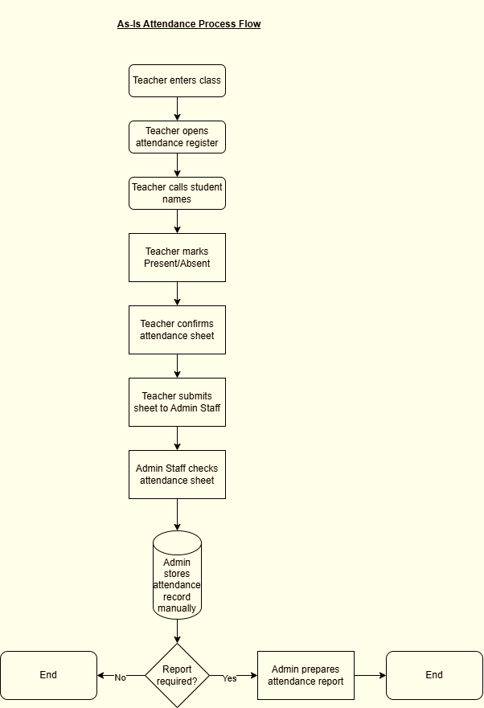
Diagram-1

Actors Involved
Teacher: Marks student attendance manually.
Admin Staff: Collects, checks and stores attendance records.
Principal / Product Owner: May request attendance summary when needed.

Current Problems
- Attendance is recorded manually.
- Admin Staff has to collect attendance from teachers.
- Attendance reports take time to prepare.
- Manual records can be difficult to search.
- Admin Staff cannot view attendance instantly.
- Attendance visibility depends on manual follow-up.
- Paper or Excel-based records may create delays or errors.

Business Impact
The current process creates manual effort for teachers and admin staff. It also delays attendance reporting and makes it difficult for the school to access attendance records quickly.

